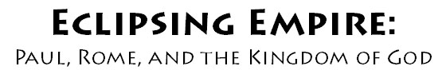

Join preeminent New Testament scholars Marcus Borg and John Dominic Crossan on location in Turkey as they trace the Apostle Paul’s footsteps throughout the Roman Empire. This 12-session DVD and web-based study explores fresh insights into Paul’s message of the Kingdom of God, its challenge to Roman imperial theology, and the apostle’s radical relevance for today. Filmed in High-Definition across Turkey, Greece, and Italy. Participant Guide written by John Dominic Crossan.

When:

Where:

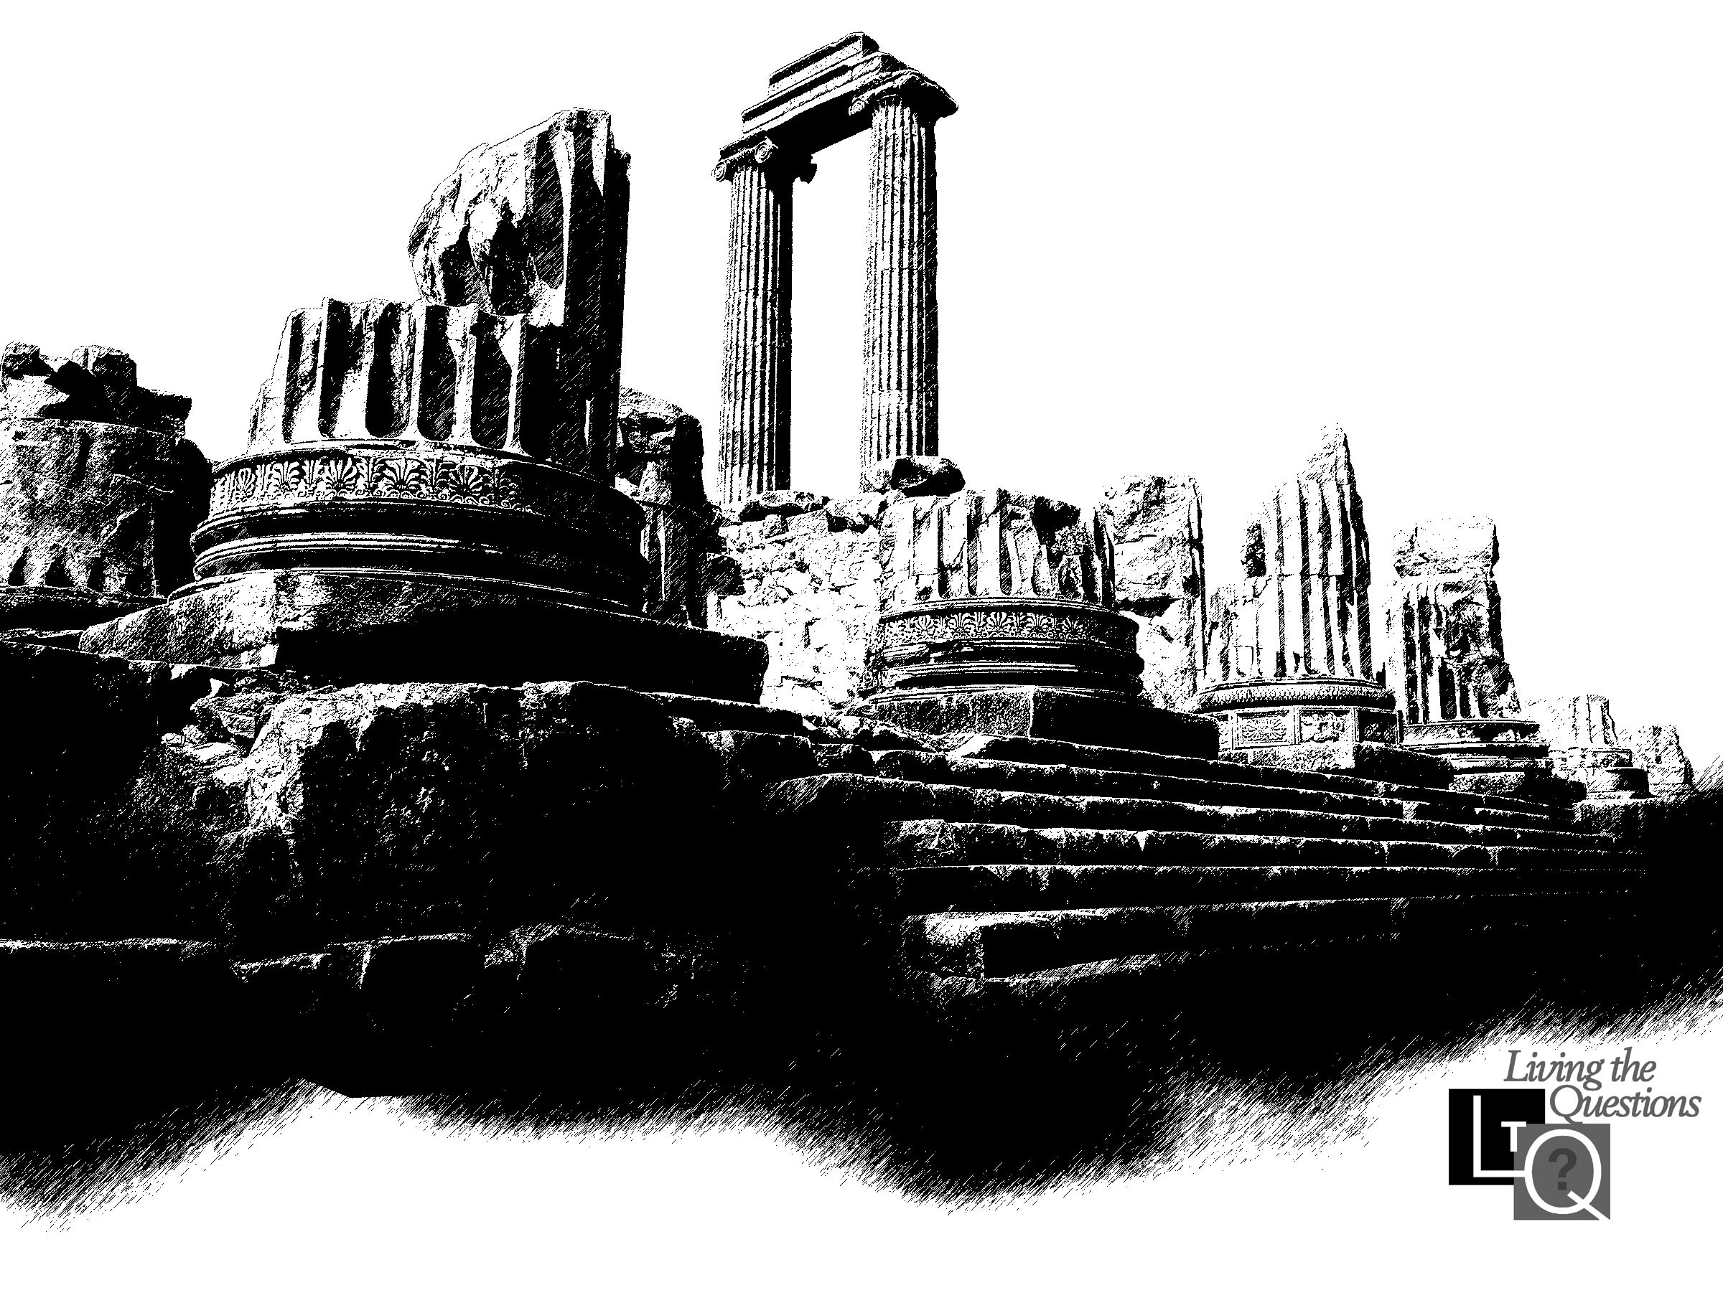
Facilitated by:

